**Project Design Phase-II**

**Data Flow Diagram & User Stories**

|  |  |
| --- | --- |
|  |  |
| Team ID | NM2025TMID07828 |
| Project Name | Optimizing User, Group, and Role  Management with Access Control and  Workflows |
| Maximum Marks | 4 Marks |

Certainly, Sirisha! Here's a tailored description of a **Data Flow Diagram (DFD)** for your project on **Role-Based Access Control and Workflow Management**:

**Data Flow Diagram (DFD) – Project Overview**

The Data Flow Diagram for this project visually represents how data moves through the system, emphasizing user roles, task management, and access control. It illustrates the flow of information between users (e.g., Project Manager and Team Members), the processes they initiate, and how data is stored or modified within the application.

**Key Elements of the DFD:**

* **External Entities**:
  + *Project Manager* and *Team Members* serve as external actors who interact with the system by creating tasks, assigning roles, and updating statuses.
* **Processes**:
  + *User Registration & Role Assignment*: Assigns roles upon registration and updates access rights. o *Task Management*: Allows creation, assignment, and status updates of tasks.
  + *Access Verification*: Validates user actions based on assigned roles and permissions.
  + *Progress Reporting*: Generates performance reports and task summaries.
* **Data Stores**:
  + *User Database*: Stores user credentials, roles, and permissions.
  + *Task Repository*: Holds all task-related information, including assignments and updates.
  + *Audit Logs*: Tracks changes in roles, permissions, and task statuses.
* **Data Flows**:
  + Data flows between users and processes, showing how a request (e.g., login, task update) travels through access validation before being stored or reflected in reports.

This DFD provides a clear visual summary of your system’s logic and data movement. If you’d like, I can help sketch it out or convert it into a

presentation slide for easier sharing.

**Example:** [**(Simplified)**](https://developer.ibm.com/patterns/visualize-unstructured-text/)

Example: **Data Flow Diagram & User Stories**

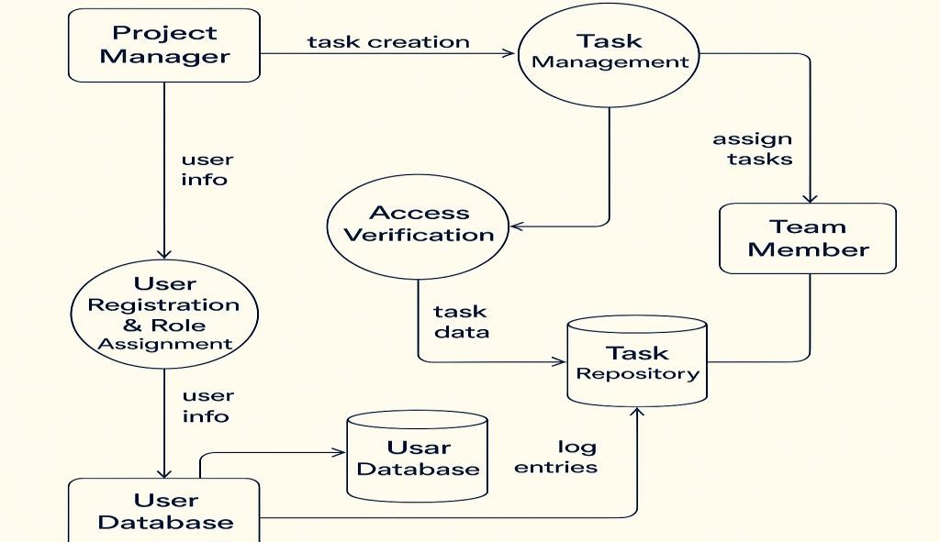

# User Stories for Role-Based Access Control System

**Functional User Story**

**User Type User Story / Task Acceptance Criteria Priority Release**

**Requirement (Epic) Number**

User & Role As an admin, I can define and assign roles Roles are assigned during user Sprint-

Administrator USN-1 High

Management (e.g., Project Manager, Team Member). onboarding and stored in the system. 1

As an admin, I can configure access levels Users see only content and features Sprint-

Administrator Access Control USN-2 High

based on user roles. relevant to their role. 1

As a PM, I can create and assign tasks to Tasks are assigned and visible only to Sprint-

Project Manager Task Assignment USN-3 High

users based on their roles. relevant users. 1

As a team member, I can view, update, and Task status can be modified and tracked Sprint-

Team Member Task Management USN-4 Medium

mark tasks as completed. by the PM. 2

As a PM, I receive notifications when a task is Notification is triggered on task status Sprint-

Project Manager Status Notifications USN-5 Medium

updated. change. 2

Project As a user, I can generate reports on project Reports display task metrics, user Sprint-

Reporting & Analytics USN-6 Medium

Manager/Admin progress and user activity. performance, and project timelines. 2

Role Update & Audit As an admin, I can modify user roles and Updated roles are reflected Sprint-

Administrator USN-7 Low

Log view change history. immediately with change logs recorded. 3